**What is Pandas?**

* Pandas is a Python library used for working with data sets.
* It has functions for analyzing, cleaning, exploring, and manipulating data.
* The name "Pandas" has a reference to both "Panel Data", and "Python Data Analysis" and was created by Wes McKinney in 2008.

**Why Use Pandas?**

* Pandas allows us to analyze big data and make conclusions based on statistical theories.
* Pandas can clean messy data sets, and make them readable and relevant.
* Relevant data is very important in data science.

**What Can Pandas Do?**

Pandas gives you answers about the data. Like:

* Is there a correlation between two or more columns?
* What is average value?
* Max value?
* Min value?

Pandas are also able to delete rows that are not relevant, or contains wrong values, like empty or NULL values. This is called cleaning the data.

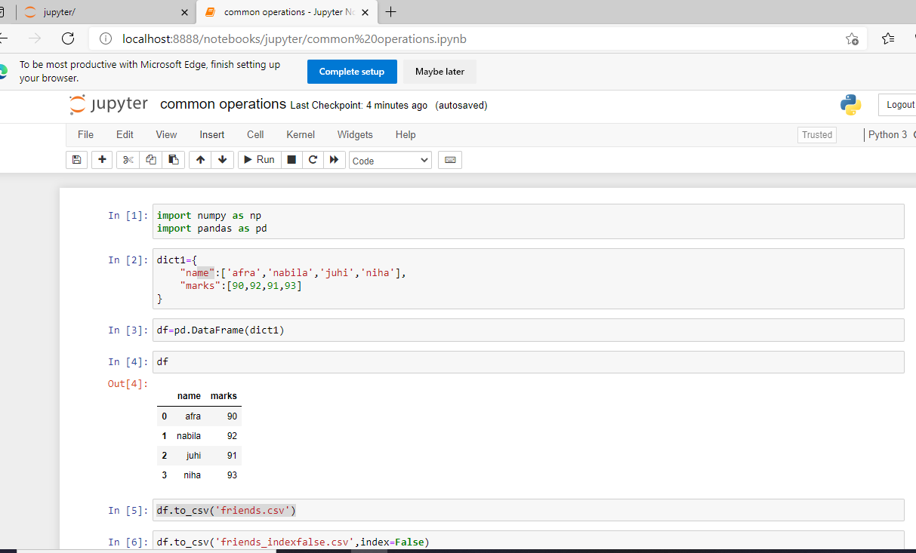

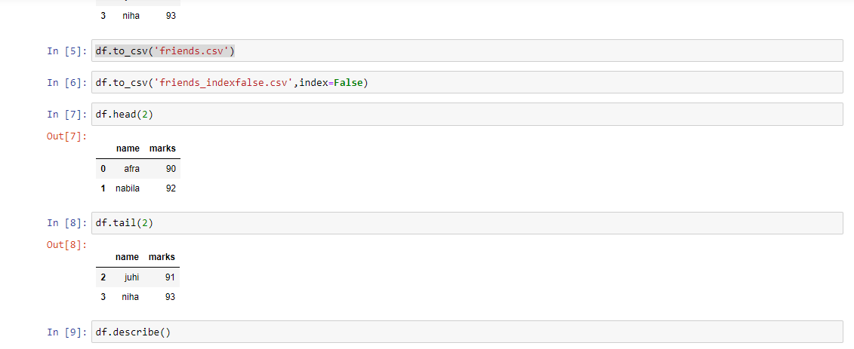

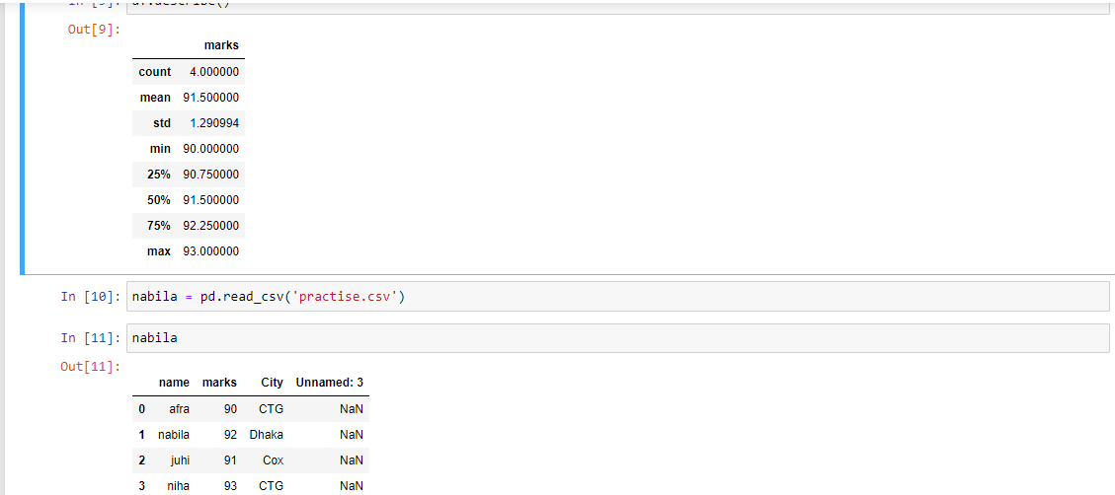

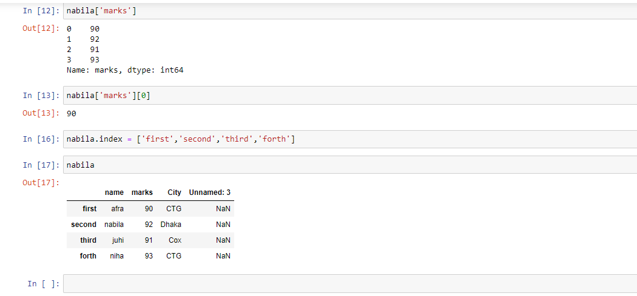

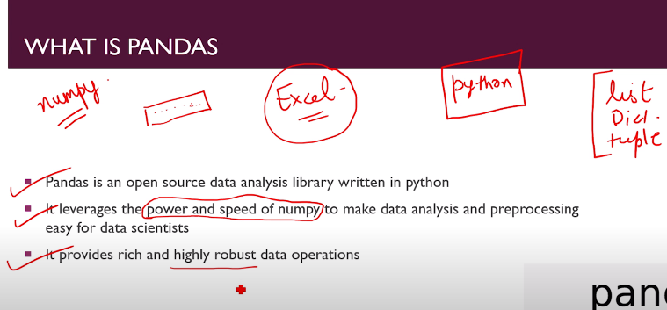

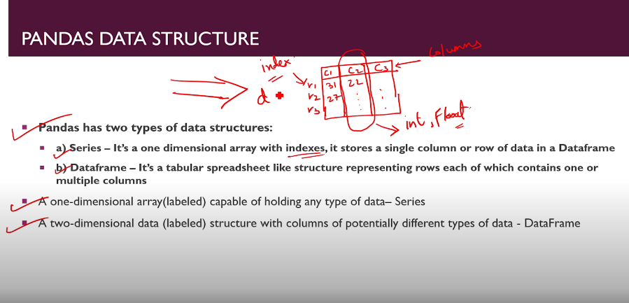

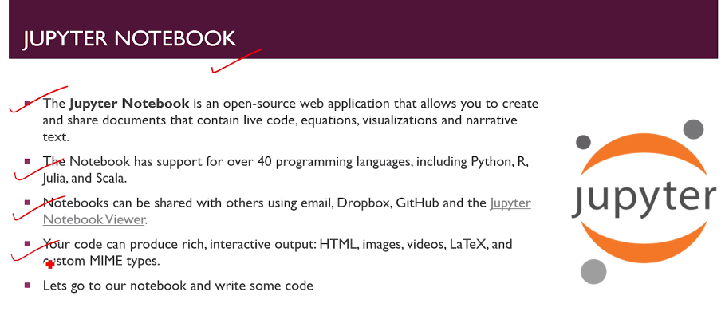

**Refenences:** 1. [***https://www.datacamp.com/community/tutorials/tutorial-jupyter-notebook?utm_source=adwords_ppc&utm_campaignid=1455363063&utm_adgroupid=65083631748&utm_device=c&utm_keyword=&utm_matchtype=b&utm_network=g&utm_adpostion=&utm_creative=332602034358&utm_targetid=dsa-473406581035&utm_loc_interest_ms=&utm_loc_physical_ms=9074040&gclid=CjwKCAjwjbCDBhAwEiwAiudBy92niLxOeoKWXUqI6zTn8rjrfstvw7CFa2Oy_JSCmdVbdrVvkRiaVhoCnfcQAvD_BwE***](https://www.datacamp.com/community/tutorials/tutorial-jupyter-notebook?utm_source=adwords_ppc&utm_campaignid=1455363063&utm_adgroupid=65083631748&utm_device=c&utm_keyword=&utm_matchtype=b&utm_network=g&utm_adpostion=&utm_creative=332602034358&utm_targetid=dsa-473406581035&utm_loc_interest_ms=&utm_loc_physical_ms=9074040&gclid=CjwKCAjwjbCDBhAwEiwAiudBy92niLxOeoKWXUqI6zTn8rjrfstvw7CFa2Oy_JSCmdVbdrVvkRiaVhoCnfcQAvD_BwE)

***2.*** [***https://realpython.com/jupyter-notebook-introduction/#:~:text=The%20Jupyter%20Notebook%20is%20an,the%20people%20at%20Project%20Jupyter***](https://realpython.com/jupyter-notebook-introduction/#:~:text=The%20Jupyter%20Notebook%20is%20an,the%20people%20at%20Project%20Jupyter)***.***